**Forgot Password Recovery In case of Entrepreneur**

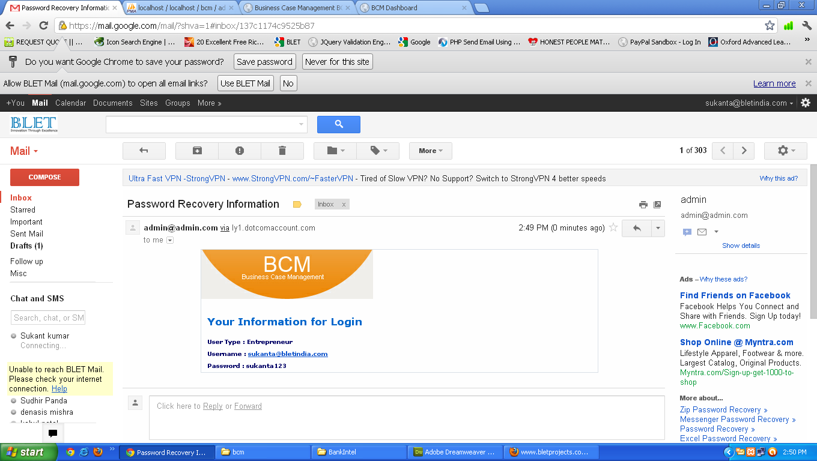

**Forgot Password Recovery In case of User**

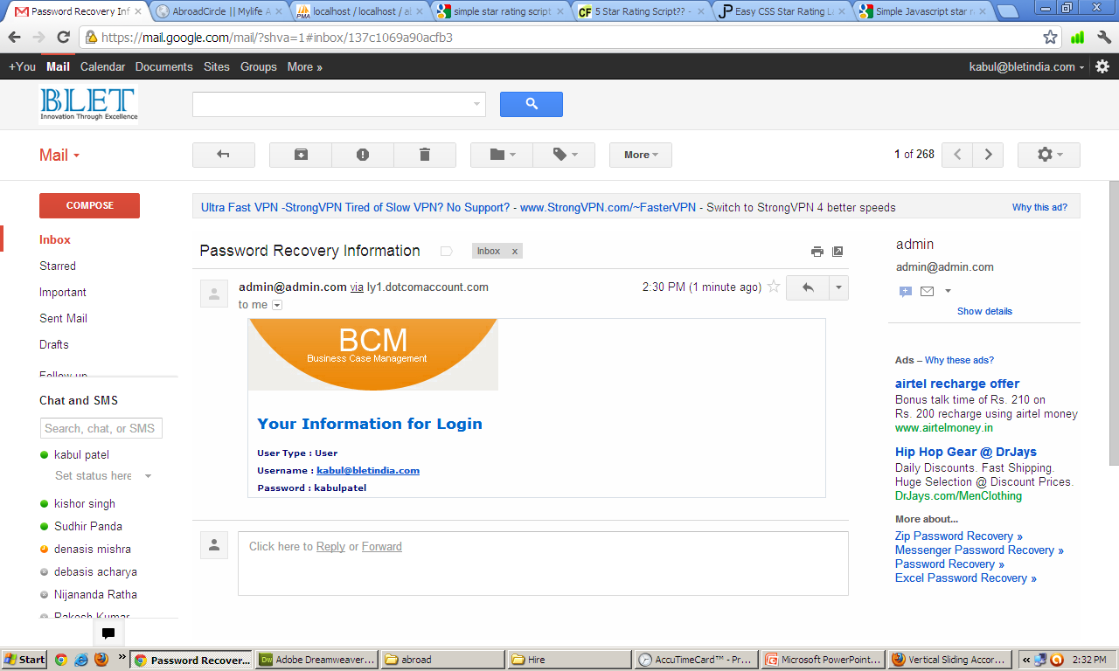

**Forgot Password Recovery In case of Administrator**

